**15B11CI212 – Theoretical Foundations of Computer Science**

**Tutorial 4**

**Relations (Posets and Hasse Diagram)**

Q1. Solve remaining questions of Tutorial 3.

Q2. Draw Hasse diagram for (D12, /) D12= {1,2,3,4,6,12} set of positive integers divisors of 12.

Q3. List the ordered pairs in the relations on {1, 2, 3} corresponding to these matrices (where the rows and columns correspond to the integers listed in increasing order).

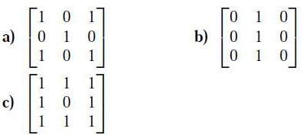

Q4. list the ordered pairs in the relations represented by the directed graph

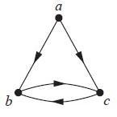

We list all the pairs (x, y) for which there is an edge from x to y in the directed graph: {(a, b), (a, c), (b, c), (c, b)}.

Q5. Which of these relations on {0, 1, 2, 3} are equivalence relations? Determine the properties of an equivalence relation that the others lack.

a) {(0, 0), (1, 1), (2, 2), (3, 3)}

b) {(0, 0), (0, 2), (2, 0), (2, 2), (2, 3), (3, 2), (3, 3)}

c) {(0, 0), (1, 1), (1, 2), (2, 1), (2, 2), (3, 3)}

d) {(0, 0), (1, 1), (1, 3), (2, 2), (2, 3), (3, 1), (3, 2), (3, 3)}

e) {(0, 0), (0, 1), (0, 2), (1, 0), (1, 1), (1, 2), (2, 0), (2, 2), (3, 3)}